## **Assignment: Multi-Level Architecture Diagramming – From Strategy to Execution**

### **🎯 Objective:**

Learn to construct a **four-level architecture diagram stack** using the Salesforce "Marketing, Strategy, and Sales" visual style for a fictional or real digital transformation initiative. Practice zooming in from high-level strategic views to detailed technical flows.

### **📘 Instructions:**

You are the Enterprise Architect for a **retail commerce digital transformation project** involving Salesforce solutions (e.g., B2C Commerce, Marketing Cloud, Service Cloud, and Loyalty Management). Your job is to **design 4 levels of architectural diagrams** that communicate your vision to both executives and implementation teams.

### **🧩 Part 1: Define Your Use Case**

Pick one of the following example domains, or choose a relevant use case from your organization:

* Retail commerce order orchestration
* Loyalty program integration with Service Cloud
* Unified customer profile using Data Cloud
* Marketing automation journey for new customer onboarding

### **📊 Part 2: Create Diagrams (Textual Representation)**

#### **🔷 Level 1: Business Capability Map**

* Identify and map the **key business capabilities** involved in the transformation.
* Example: Commerce Management, Loyalty Programs, Customer Engagement, Fulfillment, and Analytics.
* Show how Salesforce products align with each capability.

#### **🔷 Level 2: Solution Architecture Overview**

* Choose **one capability** from Level 1 and **zoom in**.
* Highlight key Salesforce products and external systems involved.
* Include **major system-to-system relationships** (but no process detail yet).

#### **🔷 Level 3: Process or Interaction Flow**

* Describe **how personas interact** with systems.
* Define the **steps in a key business process**, including handoffs and decision points.
* Example: Customer places an order → System verifies → Loyalty points awarded → Notification sent.

#### **🔷 Level 4: Technical/Data Flow**

* Provide a **fine-grained diagram** of one sub-process from Level 3.
* Include:  
  + Data flow between services
  + Events, APIs, and message queues
  + Chatbots, middleware, error paths (if any)
* Example: "Order on behalf via chat" including agent action, chat context sync, API calls, and service ticket generation.

### **🧠 Part 3: Reflection Questions**

1. How does each level of diagram help different stakeholders (Execs vs. Devs)?
2. What are the trade-offs between abstraction and detail?
3. How would you govern versioning and traceability of these diagrams?

## **✅ Deliverables**

* A 1-page summary for each level (textual or diagram via Lucidchart, draw.io, or slides)
* Answers to the 3 reflection questions
* Optional: Real or fictional Salesforce solution mapped to your diagrams

### **✅ Example Solutions Outline (Shortened)**

#### **Level 1: Capabilities**

| **Business Capability** | **Salesforce Product** |
| --- | --- |
| Commerce Management | B2C Commerce |
| Customer Engagement | Marketing Cloud |
| Loyalty & Retention | Loyalty Management |
| Service & Fulfillment | Service Cloud |
| Unified Profile & Insights | Data Cloud, Tableau |

#### **Level 2: Loyalty Management Solution**

* Loyalty Cloud ←→ Marketing Cloud
* Loyalty Cloud ←→ Customer Profile (Data Cloud)
* Service Cloud for redemptions/disputes
* External ERP for inventory sync

#### **Level 3: Loyalty Redemption Journey**

1. Customer logs into loyalty portal
2. Chooses product to redeem
3. System checks availability
4. Confirms redemption
5. Sends confirmation email/SMS
6. Logs transaction in Data Cloud

#### **Level 4: Redemption API Flow**

* REST API call → Loyalty Management
* Middleware fetches stock data from ERP
* Loyalty Cloud updates balance
* Data Cloud syncs transaction
* Marketing Cloud triggers journey

## **1. Pharmaceutical Industry**

### **🔹 Level 1 – Big Picture:**

**Digital Transformation Vision for Pharma CRM and Patient Services**

* **Business Capabilities**: Clinical Trial Management, Patient Engagement, HCP (Health Care Provider) Relationship Management, Regulatory Compliance, Drug Supply Chain
* **Salesforce Products**: Health Cloud, Marketing Cloud, MuleSoft, Data Cloud
* **Use Case**: Holistic digital ecosystem for tracking drug development, HCP outreach, and patient adherence

### **🔹 Level 2 – Piece of the Whole:**

**Capability Focus**: HCP Relationship Management

* Show: Integration of Health Cloud with Salesforce Maps and Marketing Cloud to support territory management, field rep planning, and event-based engagement

### **🔹 Level 3 – Process View:**

**Process**: New Drug Launch Workflow

* Actors: Field Reps, Medical Science Liaisons, HCPs
* Interactions: Territory planning → Outreach sequencing → Consent capture → Content delivery → Engagement scoring
* Channels: Email, In-person, Event Follow-ups

### **🔹 Level 4 – Double Click:**

**Use Case**: Adverse Event Reporting via Chat

* Details: Chatbot → Capture symptom data → Real-time compliance check → Escalation to safety team → Auto-create record in Pharmacovigilance System
* Data: Integrated with Safety Cloud, timestamped logs, auto-tagged ICD-10

## **🏦 2. Banking Industry**

### **🔹 Level 1 – Big Picture:**

**Digital Engagement & Risk Mitigation in Retail Banking**

* **Business Capabilities**: Customer Onboarding, Risk & Compliance, Loan Processing, Fraud Detection, Omnichannel Engagement
* **Salesforce Products**: Financial Services Cloud, Einstein AI, Tableau, Experience Cloud

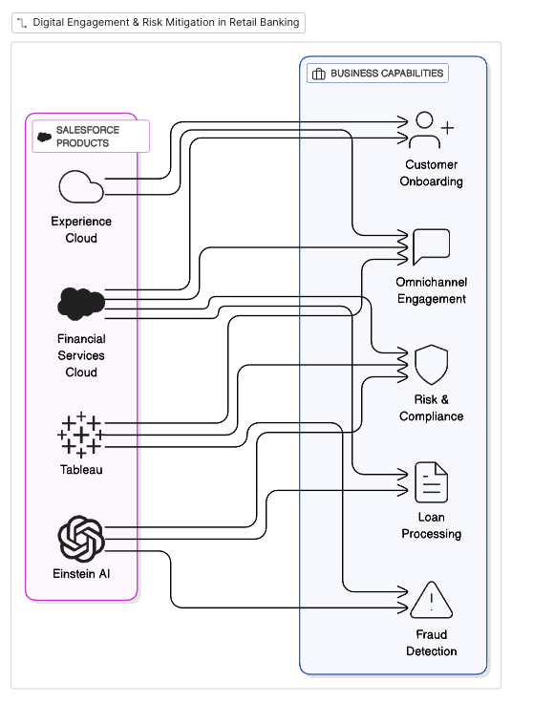

### **🔹 Level 2 – Piece of the Whole:**

**Capability Focus**: Customer Onboarding

* Show: Integration between FSC, ID verification tools (MuleSoft), and guided flows for account creation, risk profiling, and initial funding.

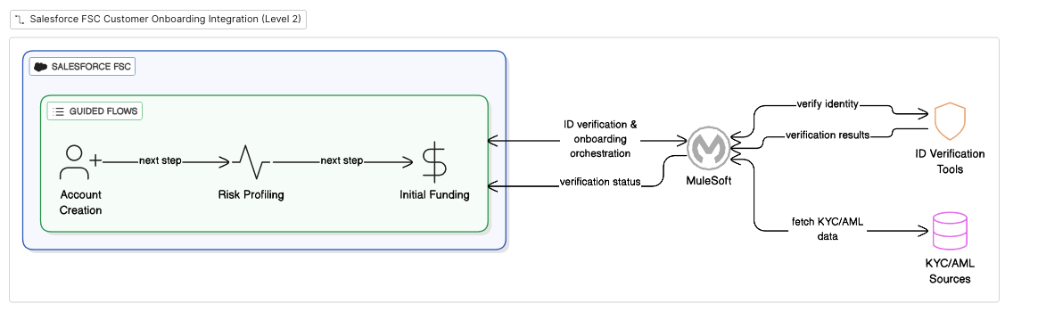

### **🔹 Level 3 – Process View:**

**Process**: Loan Pre-Approval Flow

* Actors: Customer, Credit Risk Engine, Banker
* Steps: Application form → Income verification → Credit score fetch → Risk profiling → Automated decision → Offer presented
* Tools: FSC, Data Cloud, third-party credit API

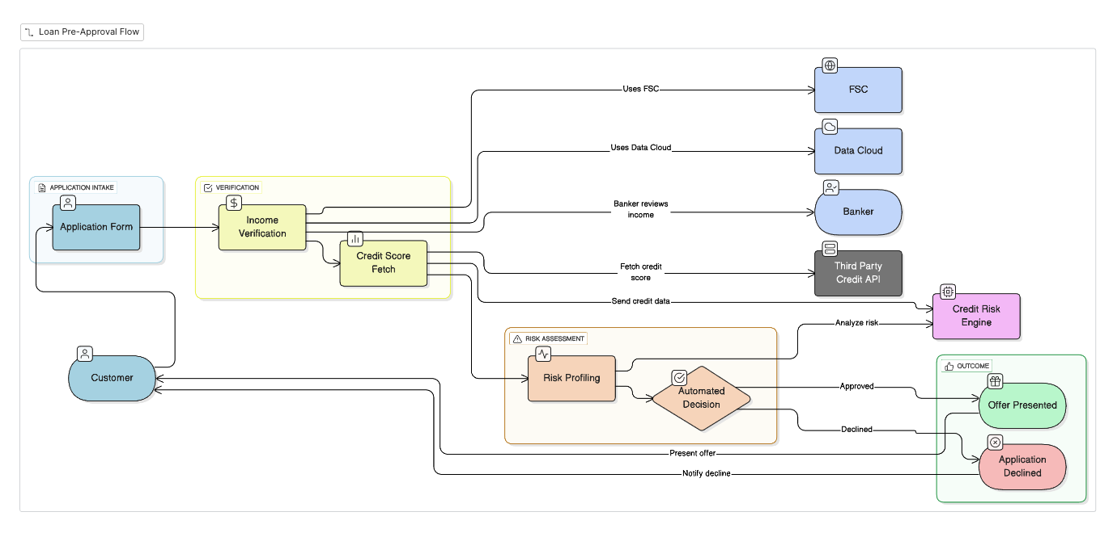

### **🔹 Level 4 – Double Click:**

**Use Case**: Chat-Based Loan Inquiry & Status Update

* Details: Conversational UI → NLP intent recognition → Auto-check application stage → Personalized response with estimated turnaround
* Data Flow: Real-time sync with Loan Origination System (LOS)

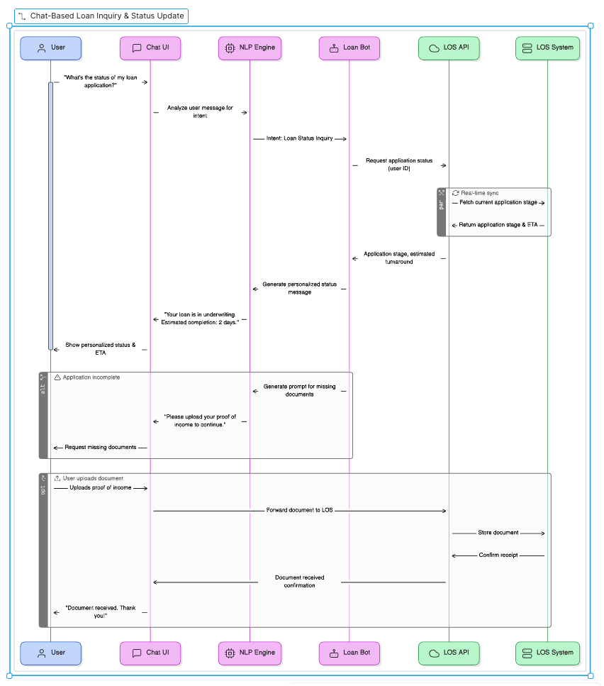

## **🏭 3. Manufacturing Industry**

### **🔹 Level 1 – Big Picture:**

**Smart Factory + Sales Enablement with AI**

* **Business Capabilities**: Dealer Management, Predictive Maintenance, Order-to-Cash, Inventory Optimization, Product Lifecycle Management
* **Salesforce Products**: Manufacturing Cloud, CPQ, Service Cloud, MuleSoft, Tableau

### **🔹 Level 2 – Piece of the Whole:**

**Capability Focus**: Order Management & Fulfillment

* Show: Connected flow between CPQ, ERP (via MuleSoft), Logistics Management, and Service Cloud for customer notifications.

### **🔹 Level 3 – Process View:**

**Process**: B2B Order Quoting to Delivery

* Steps: Product config → Quote approval → ERP sync → Production scheduling → Shipment tracking → Invoice generation
* Channels: Partner Portal, Email, ERP Events

### **🔹 Level 4 – Double Click:**

**Use Case**: Field Service Dispatch via IoT Signal

* Details: Sensor detects anomaly → Data Cloud alerts agent → Schedule repair crew → Send replacement part → Real-time repair updates via mobile
* Systems: Service Cloud + FSL + IoT APIs